Core blimey – Cubed

This is the documentation for our game that was created called cubed. In this documentation, you will find all you need to know about our game, how it was made and how the code is structured.

**Objectives**

When making our cube bases isometric survival game we had 3 core objectives for our game, these were; the game was easy to play, it got progressively difficult, and that the game had some way to progress the character each time you play through it.

We believe that these objectives have all been achieved for the game as; the game only has 4 controls, the directional keys (WASD optional) and clicking thus keeping input simple. We also added in a controls section of the menu for players to view how to play so that the games stay accessible and easy to play for everyone, this achieves the first objective.

The game is also designed in a way so that it gets progressively difficult as the waves increase so does the amount of enemy’s that spawn thus making it more difficult to kill them all before the player is overwhelmed. This achieves our second objective.

As the game progresses you can buy more items from the shop making you stronger. Increasing the effects of your bullets, speed, and buying special abilities. This achieves our final objective as it adds a form of progression.

**Rules**

The player galagos must destroy all the enemy darts each wave, galagos will not be able to leave the area has on as galagos’s flight systems have been broken. However, galagos will be able to travel around the given area and upgrade the damage capabilities of his ship. The goal is to increase your score as much as possible before dying, this game is won by maintaining the highest score.

**Gameplay**

In this game, you can move around with the WASD or the arrow keys moving the charter around a square grid. Click on the screen allows the player to shoot a bullet in that direction. The player collects scraps by killing the enemy darts and can open the shop in the middle of the game and can purchase items to upgrade themselves. Increase their currency multiplier, and even nukes to kill all enemy’s on the screen in 1 fell swoop .

**Research**

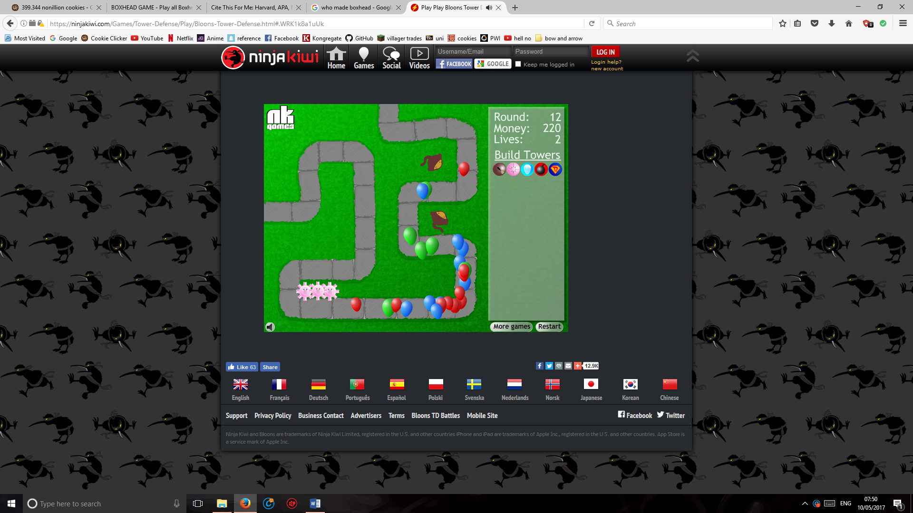one of the first games we looked at when planning our game was balloons tower defence. This game has a good use of short progression where the player can get stronger over time, although originally, we wanted to make a tower defence game we decided as we wanted to score higher in originality that we would do a survival game instead. Yet we really liked the idea of having a shop with purchasable items.

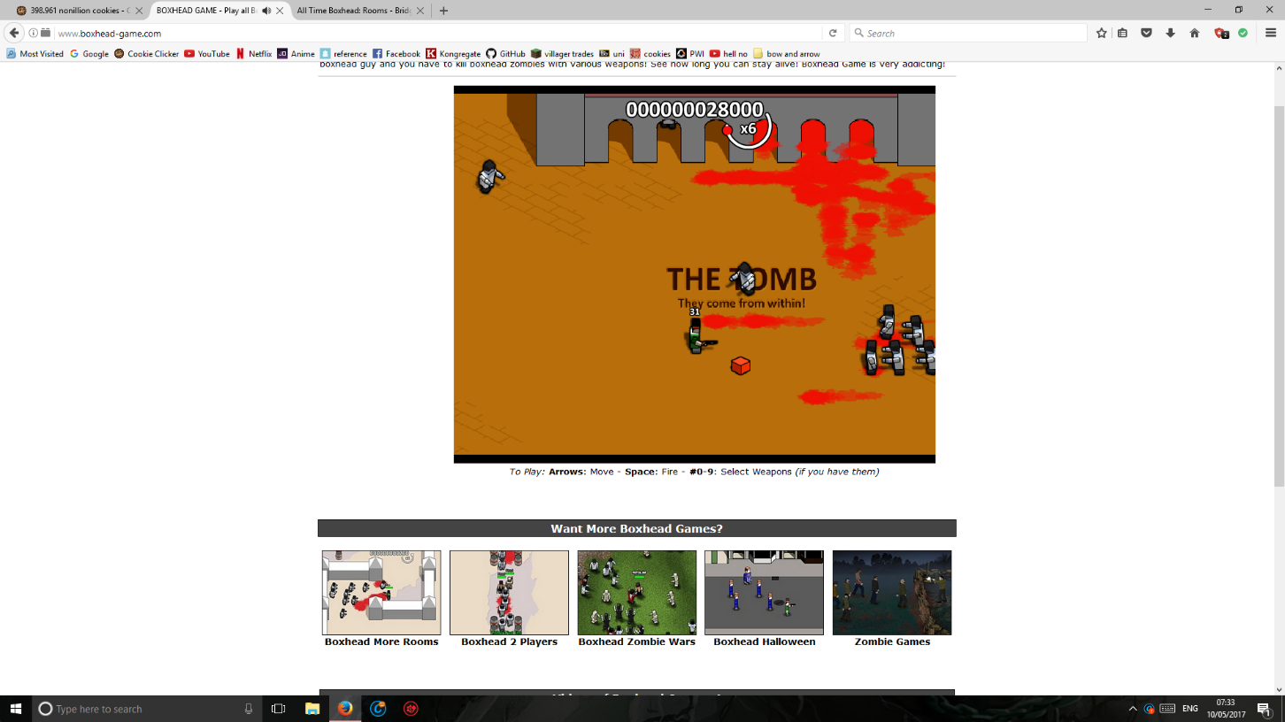

another game that inspired us was blockhead, that is a wave survival game. Where the player must fight waves of zombies and slowly unlock new attacks and score points the further they go, this then inspired us to make a score multiplier in the shop so that your score can grow experientially.

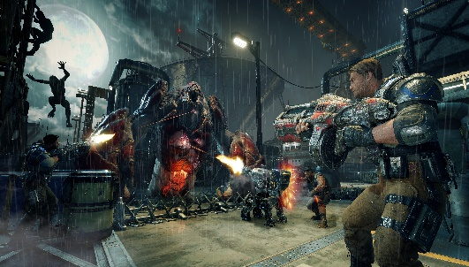

another game that we were inspired of, was the hordes mode on Gears of War where you also must fight waves and buy upgrades as you go along.

There are a lot of things that we learnt in learnt from our research we were inspired by many aspects of each of these games and incorporated them in our design, with a top down wave survival that has a shop to purchase upgrades. We decided to keep the isometric view from our original game as we felt it was unique and had good originality.

**Assets**

All assets in this game, including both sound and artwork was created by the group and it is all original with no 3rd parties used.

C:\Users\samuel\AppData\Local\Microsoft\Windows\INetCache\Content.Word\down.pngC:\Users\samuel\AppData\Local\Microsoft\Windows\INetCache\Content.Word\left.pngC:\Users\samuel\AppData\Local\Microsoft\Windows\INetCache\Content.Word\W.PNGC:\Users\samuel\AppData\Local\Microsoft\Windows\INetCache\Content.Word\A.PNGC:\Users\samuel\AppData\Local\Microsoft\Windows\INetCache\Content.Word\s.pngC:\Users\samuel\AppData\Local\Microsoft\Windows\INetCache\Content.Word\D.PNGC:\Users\samuel\AppData\Local\Microsoft\Windows\INetCache\Content.Word\up.png

These 8 images of WASD and arrow keys are all used in the controls page on the game to show the user how to control the character

C:\Users\samuel\AppData\Local\Microsoft\Windows\INetCache\Content.Word\right.png



This image of a mouse is used on the controls page of the game to show the player how to shoot.

C:\Users\samuel\AppData\Local\Microsoft\Windows\INetCache\Content.Word\ball1.5.png

These are the red cubes you get at the beginning of the game and are the most basic form of the bullet.

C:\Users\samuel\AppData\Local\Microsoft\Windows\INetCache\Content.Word\ball2.png

These 4 balls: Red, blue, yellow, and black are an upgrade of bullet and are used in the game when shooting after purchase of upgrade, they are also used in the shop to display the upgrade.

C:\Users\samuel\AppData\Local\Microsoft\Windows\INetCache\Content.Word\ball1.png

C:\Users\samuel\AppData\Local\Microsoft\Windows\INetCache\Content.Word\ball3.png

C:\Users\samuel\AppData\Local\Microsoft\Windows\INetCache\Content.Word\ball5.png

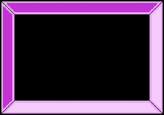

This is the background for the home screen.

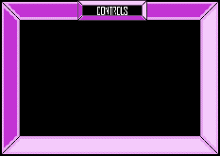

This is the background for the controls screen.

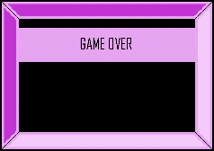

This is the background for the game over screen.

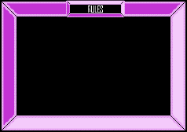

This is the background for the rules screen.

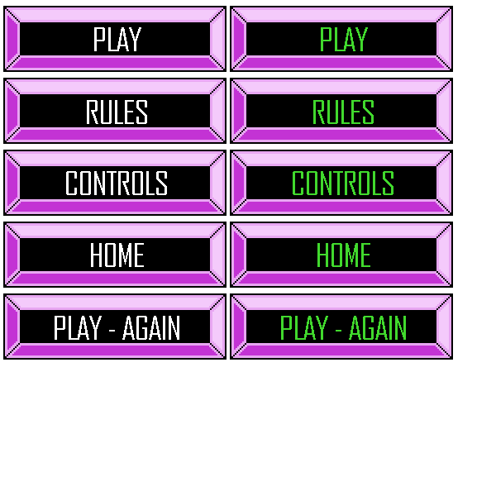

This is a sprite sheet for all the buttons in the game with the static buttons on the left and the green text on the right to indicate there being hovered over.



This is the button used to open and close the shop.

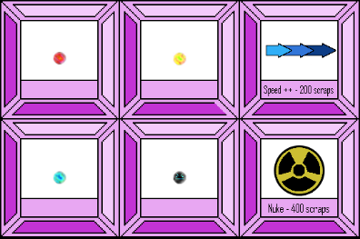

This is the shop where it lists all purchasable products.

C:\Users\samuel\AppData\Local\Microsoft\Windows\INetCache\Content.Word\turret1.2.png

This is the turret that the player shoots bullets from.



This is the base of the player that the player can move around with.



This is the cube tile that makes up the floor that the player can stand on.

**Why the change?**

When creating our initial design we planned on making an isometric tower defense. However, when we did our initial presentation we saw that multiple other groups had also decided to create tower defense games. Because of this, we decided to take our base concept and redesign it to a horde mode game, keeping only the isometric view and shop concepts. This challenged us to be more original.

**Functions**

The Create function we use to creating our assets by calling the sprites from the preload function.

The Update function is what we use to handle all game updates.

The spawnTiles function is used for drawing the base tilemap.

The render function is used to monitor how long till the next wave spawns and test to see if it spawned.

The reset timer function will reset the games timer

The fire function handles creation of bullets when the player fires his gun.

The updatehighscore function updates the high score if a new one has been reached

The unpause function handles the shop in the game and will deal with purchasing new upgrades and power ups., this function makes calls to changeWeapon2, changeWeapon4 and changeWeapon5. These allow you to change sprites mid game to use the newly brought power ups.

# Bibliography

Ang, C. (2017). *Rules, gameplay, and narratives in video games*. [online] researchgate. Available at: https://www.researchgate.net/publication/236870305_Rules_gameplay_and_narratives_in_video_games [Accessed 9 May 2017].

Hernandez, P. (2017). *Gears Of War 4's Horde Mode Is A Blast*. [online] Kotaku.com.au. Available at: https://www.kotaku.com.au/2016/10/gears-of-war-4s-horde-mode-is-a-blast/ [Accessed 10 May 2017].

Cooper, S. (2017). *BOXHEAD GAME - Play all Boxhead Games, The Rooms, etc.*. [online] Boxhead-game.com. Available at: http://www.boxhead-game.com/ [Accessed 10 May 2017].

Ninjakiwi. (2017). *Bloons Tower Defense*. [online] Available at: https://ninjakiwi.com/Games/Tower-Defense/Play/Bloons-Tower-Defense.html [Accessed 10 May 2017].